## Instructions

The task is vector only, to be created in Illustrator.

Target group: children all over the world age 9–15.

Task 1 & 2 must fit on 1 sheet A3 paper

Artwork Colours: Pantone Solid Coated colours only

Dieline Colours: Spot colours only

A child between the ages of 9–15 must be able to assemble the tasks without assistance.

You must add arrows, numbers or other signs to explain the assembly of both tasks on the CUT layer. The instructions must be on the CUT spot colour on the CUT layer.

Include icons or illustrations for the CUT, FOLD & GLUE instructions. No text must be included.

Example:

~~      ~~

### Task 1

Any shape allowed.

The design must only be one sided.

CUT lines: spot colour, stroke weight 1pt on separate CUT layer in Illustrator and pdf.

Name colour and layer CUT LINES.



*\* sample showing cut lines on coloured background. You may choose any spot colour that will have enough contrast to your background colour*

FOLD lines: Spot colour 0.5pt dashed line. On separate layer in Illustrator and pdf.

Name of colour and layer: FOLD LINES



*\* sample showing dashed fold line on colour background. You may choose any PMS colour that will have enough contrast to your background colour*

GLUE: Indicate glue points with a circle — 0.5pt stroke only, no fill colour.

Use spot colour, name the colour and layer: GLUE

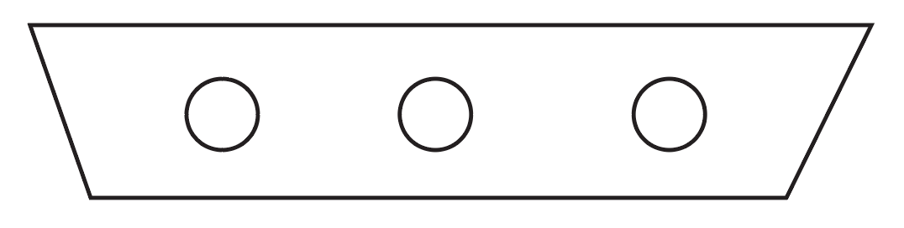

Bleed: 3 mm

### Task 2:

(On the same A3 artboard as task 1)

You must make a front and back — but they must only use the one artboard (together with task 1).

Make them foldable any way you choose.

You can make either 2D or 3D, but they must be able to stand alone (self standing).

Use the same layers and colours for CUT LINES, FOLD LINES and GLUE as task 1.

No bleed required

**You must deliver:**

1 Illustrator file A3 artboard containing 5 layers

Layer: Task 1

Layer: Task 2

Layer: CUT LINES

Layer: FOLD LINES

Layer: GLUE

1 PDF/X-4:2010 with layers

Include your competitor number in the final file on CUT lines layer.

Task 1: assembled mock-up including prop placed inside package.

Task 2: assembled mock-ups.